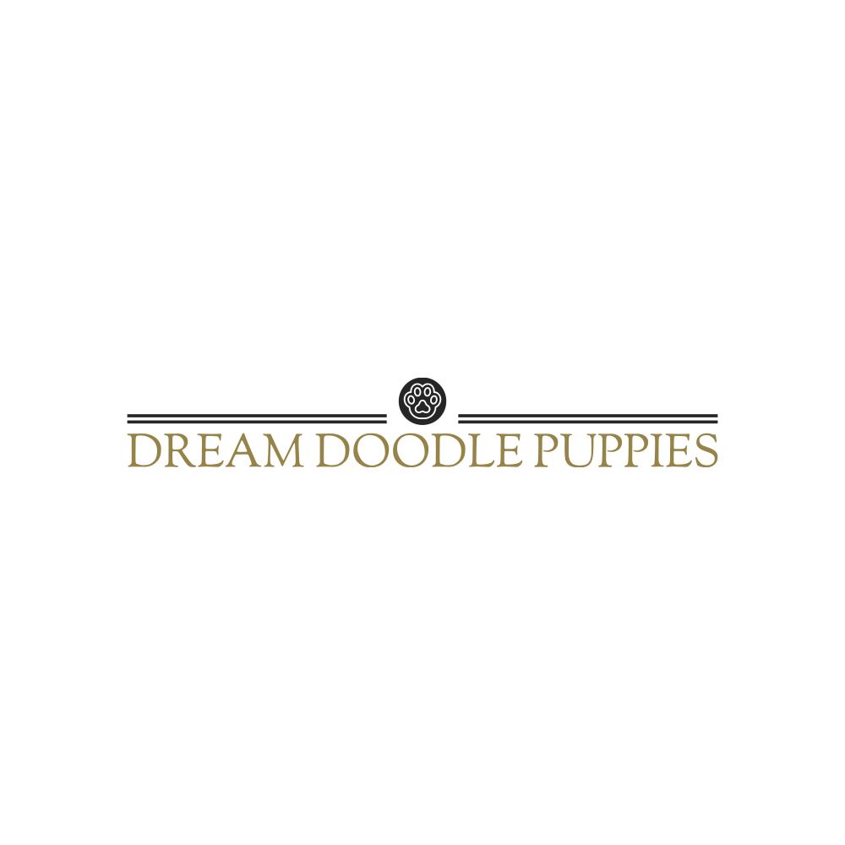**-PUPPY HEALTH GUARANTEE/CONTRACT AND TERMS-**

Thank you so much for considering us and for adopting your sweet little puppy through us! We trust you will completely fall in love with your new forever fur friend. This document includes all the information about your new puppy’s health guarantee and our terms.

Puppy Name/collar color_____________________________Buyer___________________________

Purchase Price $______________________________ Date of Sale:___________________________

The health and happiness of your puppy is very important to us. As of date of delivery/pick up, your puppy will have received all the recommended vaccinations, dewormings, and will have a health exam and report done by our licensed veterinarian. Your puppy will also have received early neurological stimulation and be lovingly socialized with our 4 children here in our home and come with a complete puppy starter pack including their health records, a collar, a 5 lb bag of Hills Bro Science Diet puppy food, a chew toy, and a sibling scented blankie. We have been giving your puppy NuVet vitamins and so we highly recommend keeping them on these vitamins for optimal health. **Health guarantee is null and void if the NuVet vitamins are not continued**. Being proactive with their health can prevent many issues down the road. Buyer is responsible to take the puppy to their vet for an initial puppy exam within 1 week of pick up/delivery date. We do offer a two-year genetic health guarantee with your puppy. This guarantee does not include common puppy issues like coccidia,(which is caused by stress) worms, giardia, ear mites, or UTIs, underbites, undescended testicles, or umbilical hernias. This guarantees that your puppy will **be free of all major/life threatening or genetic issues within two years of the purchase price/pick up date.** We must be notified within 2 business days of a licensed veterinarian’s determination of a life threatening or life altering condition, along with a veterinarian’s report and contact information for your veterinarian. There are certain disorders that may be caused by environmental factors such as allergies, thyroid issues, and other autoimmune disorders that this guarantee does not cover. Luxating patella’s must be diagnosed on the first initial puppy exam. We only cover stage 3 and above. If a major genetic or life-threatening issue may arise within those first two years, we will take the puppy back and refund your money in full or replace the puppy from a future Dream Doodle Puppies litter.

In the event that the puppy may no longer be available due to sickness, death, unsuccessful breeding, or any other circumstance due to the fault of the seller, the buyer’s deposit will, **at the buyer’s option**, either be **fully refunded** or **transferred** to another litter.

Though our purebred adult dogs are AKC registered, Bernedoodles and Goldendoodles are inherently a mixed breed, therefore we do not register our puppies, as AKC does not register mixed breeds. We cannot completely guarantee the size, color, or the temperament of your puppy, although we do our **absolute best** to make the most reasonable guess based on our past litters and puppies.

All sales have 7.5% sales tax added, if applicable. Tax total $____________________________

We offer ground delivery for .85 a mile round trip for driving/meeting half way/etc if you would like us too. We can also fly your puppy in cabin to your nearest major airport. Contact us for rates on air delivery. Prices vary depending on your location. Delivery fee $____________________________

The expected pickup date is _____________________. We can keep and care for the puppy for free for up to 1 week past this pick-up/delivery date. If it goes past the 1 week mark, we charge $15.00 a day boarding costs until buyer picks up puppy. Boarding cost $_________________________.

**We do not schedule any puppy selections, deliveries, airport meetings, and home pick ups on Sundays.**

Puppy Purchase Total, including tax, delivery, etc $__________________________.

Buyer has paid a **NON-REFUNDABLE** deposit of $___________________________.

You can pay the deposit via Paypal to [dreamdoodlepuppies@yahoo.com](mailto:dreamdoodlepuppies@yahoo.com) or mail a personal check to: **Dream Doodle Puppies 11800 S Halstead St Hutchinson, KS 67501** This deposit will go towards the payment of the puppy, with the remaining balance of $______________________. The remaining balance is due **IN CASH ONLY** upon the release/pick up of the puppy. No checks accepted for the remaining balance. **If you choose to pay the full amount through PayPal, the full payment must be made 1 week prior to pick up day.**

Buyer:__________________________________________________________________________

Address:________________________________________________________________________

Phone:____________________________ Email:________________________________________

Name of Puppy/collar color:_____________________________ DOB:________________________

Color/Coat:_______________________________________ Sex: M F

Mother’s Name:__________________________ Father’s Name:_______________________

Litter:__________________________________

**Buyer Signature**____________________________________________________

**Seller Signature**___________________________________________________

Dream Doodle Puppies: Gary Lehman- 620.899.1478 Marlene Lehman 620.899.3173